**Appendix 2**. Relationship between total number of eBird checklists and the total species richness in a city.

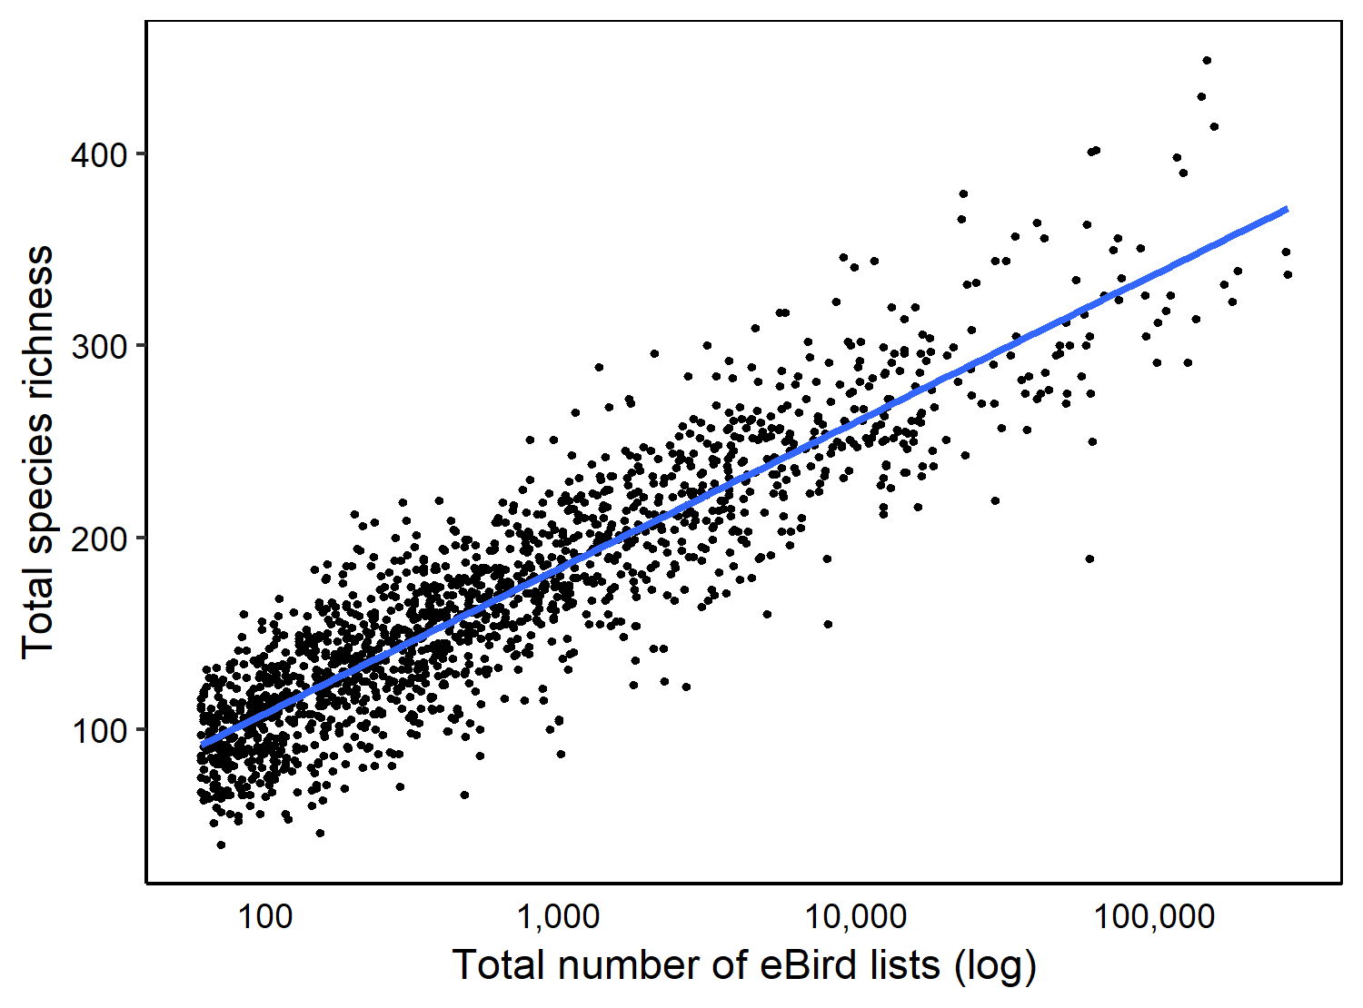

**Figure A1**. Relationship between number of eBird lists submitted in a city and the total number of species richness submitted from the city.